Due: 18 – 02 - 2024

Total Marks: 20 (3.3% Weightage)

Task: Your job is to design an Arduino Uno based system for the following problem. Design the circuit in Tinker cad simulator (https://www.tinkercad.com/dashboard). Pick one task according to your roll number.

**Student with odd roll number (L200921)**

Build a traffic light and pedestrian boom-gate system for a busy road. Due to high vehicular traffic, the signal normally stays green, and the boom-gate remains closed. When any pedestrians arrive to cross the road, a PIR motion sensor detects them, and once at least 60 seconds have passed since signal turned green, the system turns the traffic signal to yellow-then-red, and the boom gate then opens. When the sensor no longer detects pedestrians, or after 30 seconds (whichever is earlier), the traffic light changes to yellow-then-green and boom gate closes.

Note the timing requirements:

* Yellow light duration: 3 seconds
* Minimum time signal stays green: 60 seconds
* Maximum time signal stays red: 30 seconds

Components to be used on Tinker cad: PIR sensor, LEDs (for traffic lights), micro servo (for boom gate). How to keep track of time: <https://docs.arduino.cc/built-in-examples/digital/BlinkWithoutDelay/>

***Deliverables***

In Tinker cad, generate a sharing link (https://www.tinkercad.com/blog/tinkertips-share-link) for your circuit. Do NOT make the design public, or share the link publicly.

You should submit a PDF document containing:

* The design links
* Screenshots of both the circuit and the schematic.
* A copy of Arduino source code.

For assignment evaluation, you will be asked to demonstrate working of the circuit and explain your code/logic.

**SOLUTION**

***SOURCE CODE:***

//L200921 Aisha Muhammad Nawaz - IIOT A1 BSCS 8A Spring 2024

/*

-> ODD ROLL NUMBER QUESTION:

Build a traffic light and pedestrian boom-gate system for a busy road. Due to high vehicular traffic,

the signal normally stays green, and the boom-gate remains closed. When any pedestrians arrive to

cross the road, a PIR motion sensor detects them, and once at least 60 seconds have passed since

signal turned green, the system turns the traffic signal to yellow-then-red, and the boom gate then

opens. When the sensor no longer detects pedestrians, or after 30 seconds (whichever is earlier),

the traffic light changes to yellow-then-green and boom gate closes.

Note the timing requirements:

• Yellow light duration: 3 seconds

• Minimum time signal stays green: 60 seconds

• Maximum time signal stays red: 30 seconds

*/

#include <Servo.h>

int ON=255;

int OFF=0;

//<--- LEDs --->

int led_red=3;

int led_green=2;

int redState, yellowState=OFF;

int greenState=ON;

//<--- PIR SENSOR --->

int pirSensor=A4;

int pirState;

//<--- BOOM GATE --->

int gate=A5;

int posGate; //loop Variable

Servo servoGate;

int gateStatus=0; //0 for Gate Closed, 1 for Gate Opened.

//<--- Intervals --->

unsigned long lastTimeRed,lastTimeGreen=0; // To store the last time the LED was updated

const long yellow_interval = 3000; //3 sec

const long green_interval = 60000; // Min time 60 sec

const long red_interval = 30000; // Max time 30 sec

void setup()

{

pinMode(led_red, OUTPUT);

pinMode(led_green, OUTPUT);

pinMode(pirSensor,INPUT);

servoGate.attach(gate);

analogWrite(led_green,greenState); //Initially Green Light ON

}

void openGate()

{

for (posGate=90;posGate>=0;posGate=posGate-2) //Rotating Gate to open

{

servoGate.write(posGate);

delay(20);

}

gateStatus=1; //Updating status of gate to open i.e 1

}

void closeGate()

{

for (posGate=0;posGate<=90;posGate=posGate+2)//Rotating Gate to close

{

servoGate.write(posGate);

delay(20);

}

gateStatus=0; //Updating status of gate to close i.e 0

}

void loop()

{

//Getting Current Time

unsigned long currentTime = millis();

//Read PIR Sensor State

pirState=digitalRead(pirSensor);

if(pirState==HIGH)// If motion detected

{

if (currentTime - lastTimeGreen >= green_interval) //If green interval passed

{

if(greenState==ON)

{

//Open Gate (If it is Closed)

if(gateStatus==0){openGate();}

//Turn on Yellow light

analogWrite(led_red,ON);

redState=ON;

yellowState=ON; // Note: Red+Green light on means Yellow Light

delay(yellow_interval); // Let yellow light on till yellow interval

//Turn on Red light

greenState=OFF;

analogWrite(led_green,greenState);

lastTimeRed=millis(); //Update lastTime changed to Red to current time

}

}

}

else if((pirState==LOW) || (currentTime - lastTimeRed >= red_interval))//If no motion detected or red interval reached

{

if(redState==ON)

{ //IF RED ON

//Turn on yellow light

greenState=ON; //as Green+RED = Yellow

yellowState=ON;

analogWrite(led_green,ON);

delay(yellow_interval); // Let yellow light on till yellow interval

//Turn off red light

redState=OFF;

analogWrite(led_red,redState);

// Save the last time state changed of RED

lastTimeRed = millis();

//Close Gate (If it is opened)

if(gateStatus==1){closeGate();}

}

}

}

**MY DESIGN LINK:**

https://www.tinkercad.com/things/5UBoVRgZkEH-l200921a1iiot8abscs?sharecode=PM1K1eoWCNJLz0ifpw_TLRVxpZT2KCYgVMDvIcq38uQ

***SCREENSHOTS (OF BOARD)***

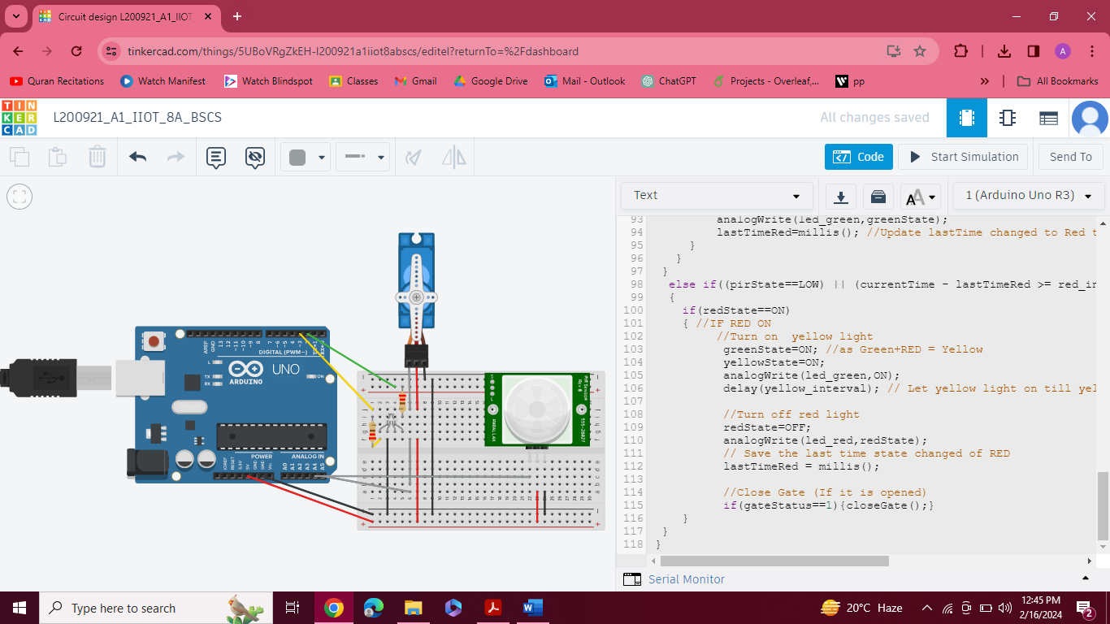

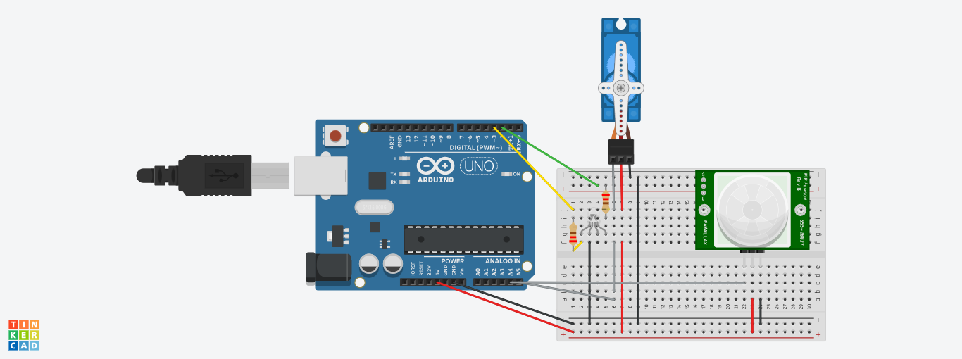

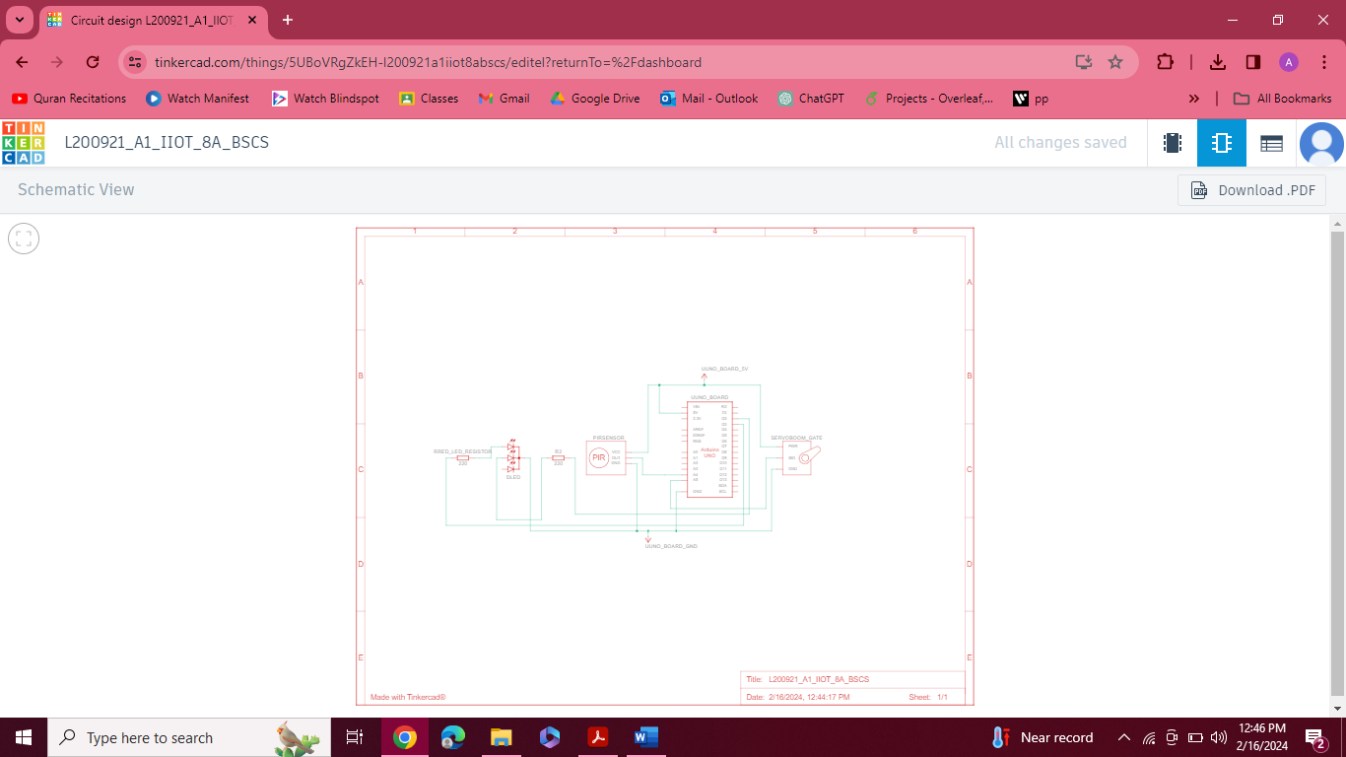

**(**SCHEMATIC VIEW IS ALSO MORE CLEARLY ATTACHED AT END)**

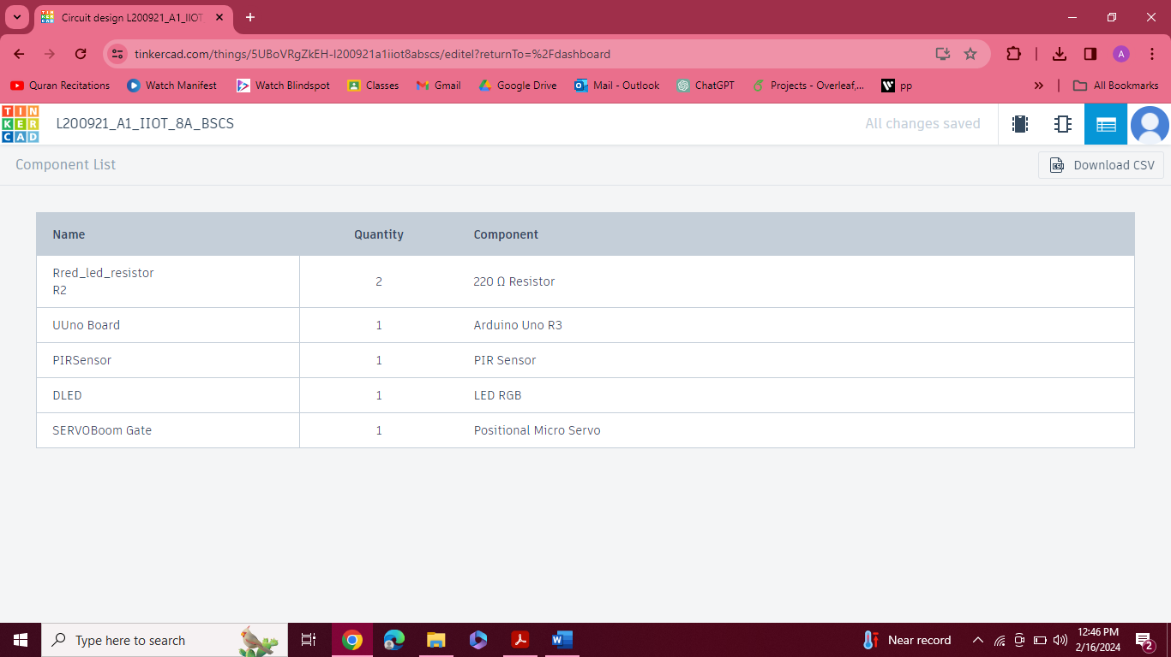

***SCREENSHOTS (OF WORKING)***

* **Green Light ON & Boom Gate Closed (No Motion Detected)**

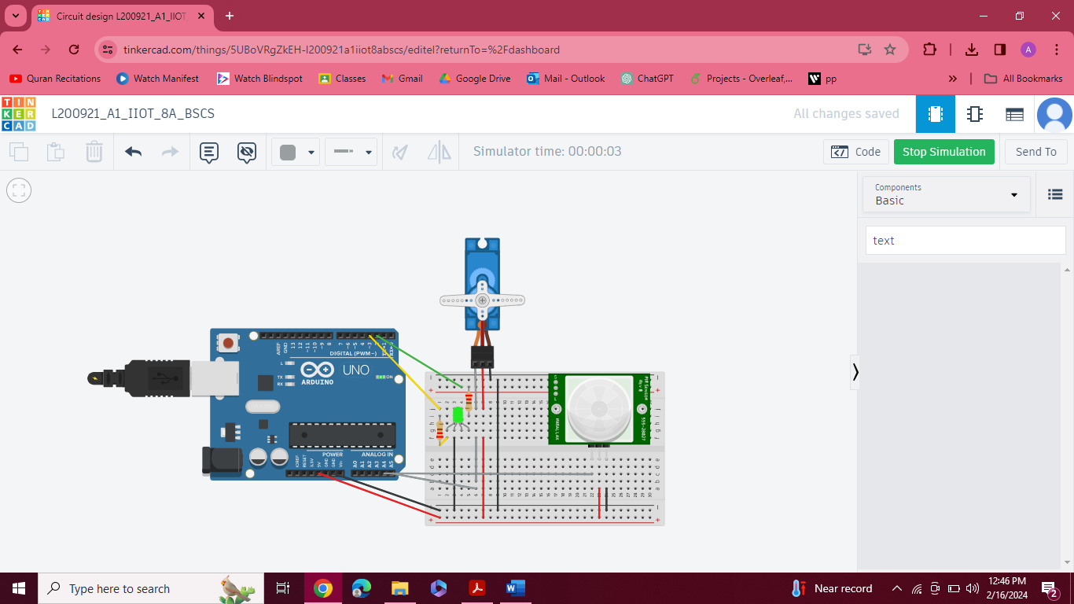

* **Green Light won’t change & Gate won’t open till 60 secs of green light passed even if motion detected**

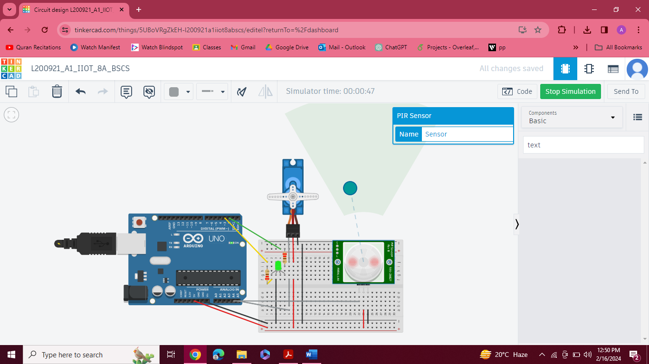

* **Yellow Light ON & Boom Gate Opens (Motion Detected & 60Secs Passed till Green Light ON)**

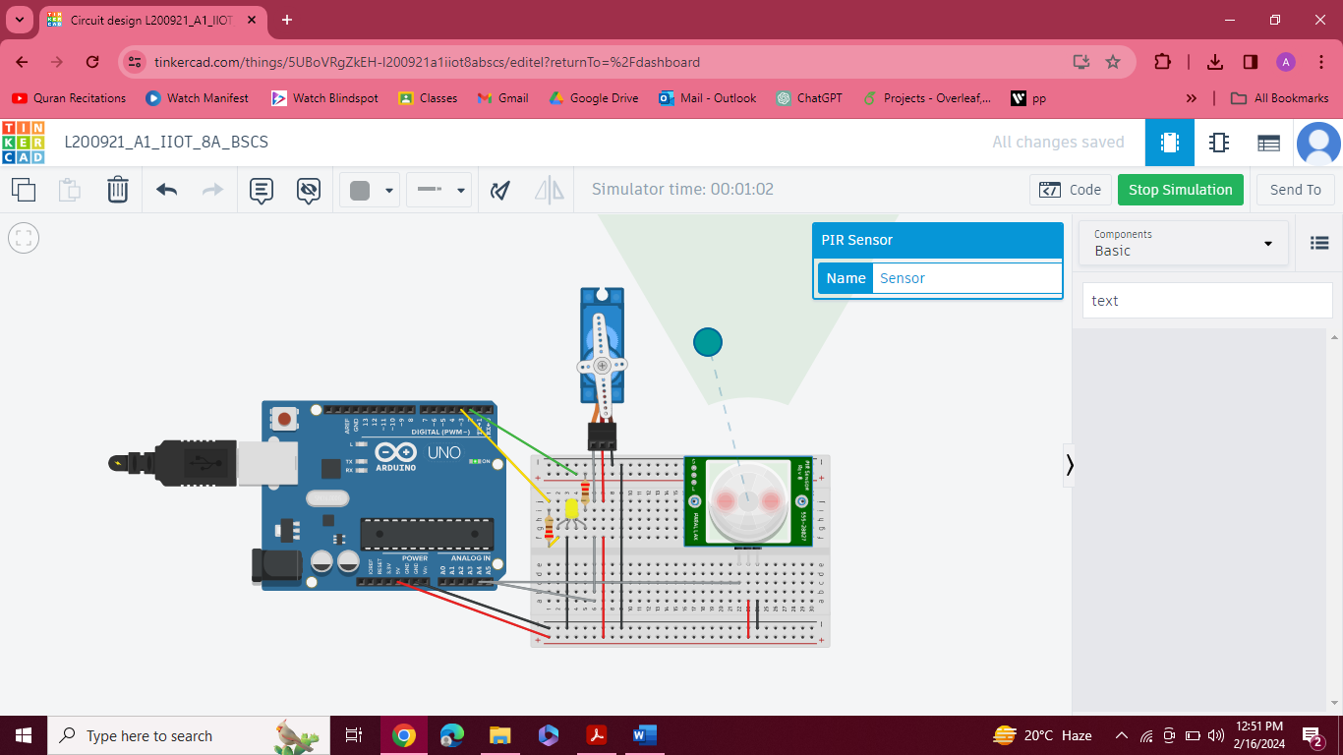

* **RED LIGHT (After 3secs of yellow light)**

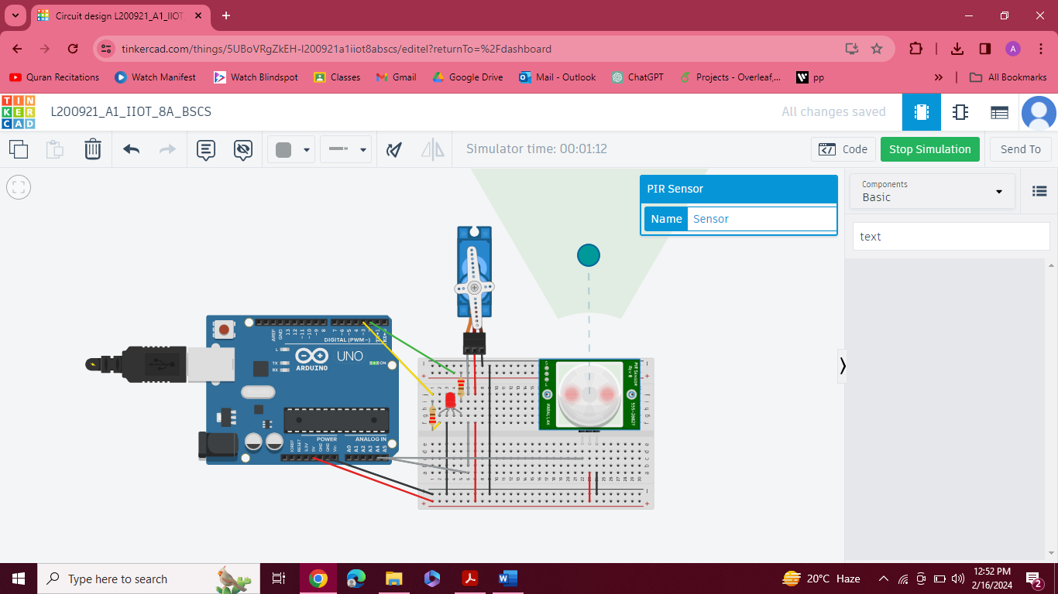

* **Yellow Light on (After 30 secs of Red Light & No motion detected)**

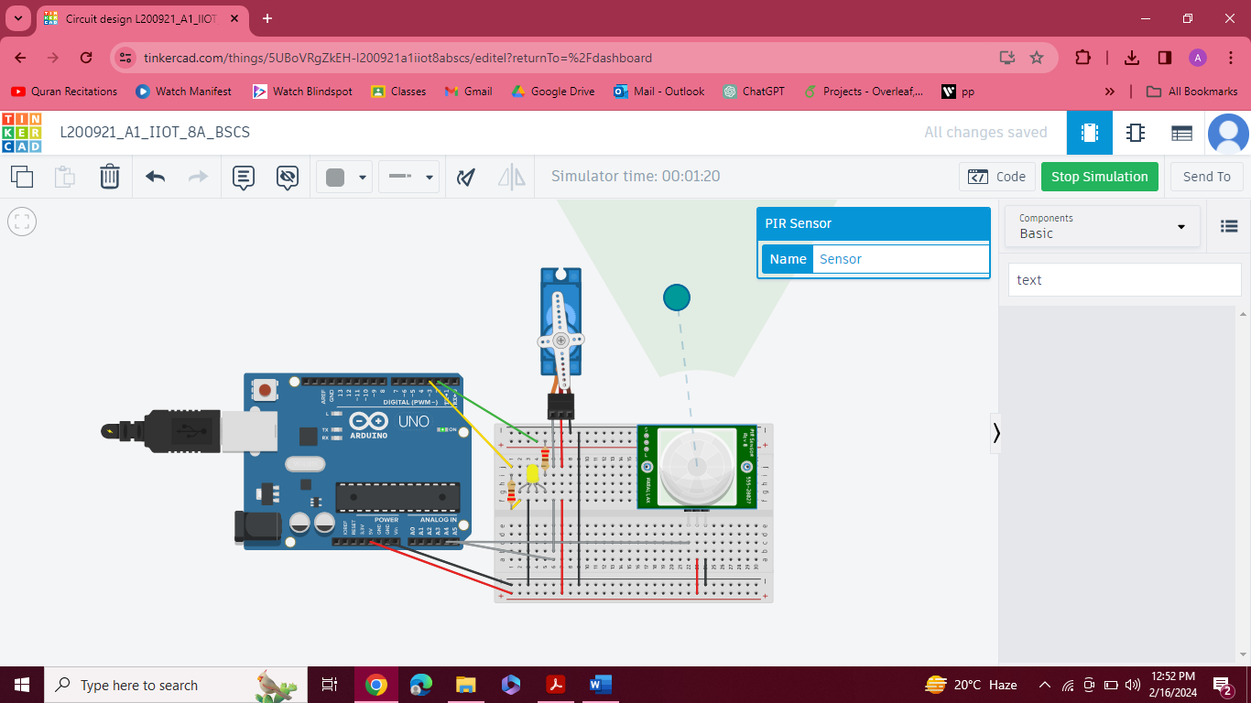

* **GREEN Light Back on after 3 secs of yellow light & GATE CLOSES**

